|  |  |  |  |
| --- | --- | --- | --- |
| **F:\Learning bugs\Foundation Subjects\Dolly the Fly - Science.jpgLyng Primary School Knowledge Organiser** | | | |
| **Topic: Movement and nutrition** | **Science**  **How do our bodies function?** | Year 3 | Autumn 1 |



**Notable scientists**

**Charles Darwin**

He developed the theory of evolution. 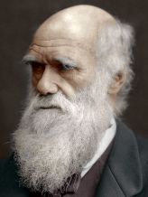

**What should I already know?**

* Identify and name a variety of common animals that are carnivores, herbivores and omnivore.
* Notice that animals, including humans, have offspring which grow into adults.
* Identify that most living things live in habitats to which they are suited and describe how different habitats provide for the basic needs of different kinds of animals and plants and how they depend on each other.
* Describe how animals obtain their food from plants and other animals, using the idea of a simple food chain, and identify and name different sources of food
* Describe the importance of exercise, eating the right amounts of different types of food and hygiene

|  |  |
| --- | --- |
| **What Step On and Goldilocks words will I use?** | |
| **Spelling** | **Definition** |
| skeleton | The set of bones on a human or animal, joined together to make our structure. |
| tendon | A tough, elastic tissue which connects the muscles and bones |
| voluntary muscle | Muscles whose actions are controlled by an individual’s will |
| involuntary muscle | Muscles not controlled by an individual’s will. |
| Vertebrate | Animal with a backbone |
| Invertebrate | Animal without a backbone |
| Joints | Areas where two or more bones are fitted together |
| balanced diet | a diet consisting of the proper quantities and proportions of foods needed to maintain health or growth |
| healthy | Someone who is **healthy** is well and is not [suffering](https://www.collinsdictionary.com/dictionary/english/suffering) from any [illness](https://www.collinsdictionary.com/dictionary/english/illness). |
| nutrients | Nutrients are substances that help plants and animals to grow. |
| energy | Energy is the ability and strength to do active physical things and the feeling that you are full of physical power and life. |

|  |
| --- |
| **Investigate!** |
| * Record findings using simple scientific language, drawings, labelled diagrams, bar charts and tables – **create our Iron Man Skeleton.** * Ask relevant questions – **hot seat a member of staff about their dietary requirements.** |

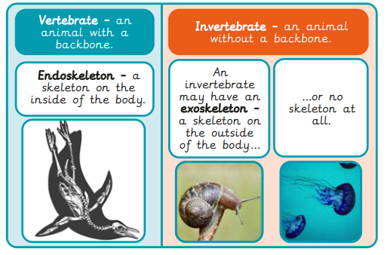

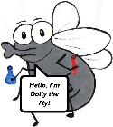

**What will I know by the end of the unit?**

**Food pyramid**

**Muscles**

**Skeleton**

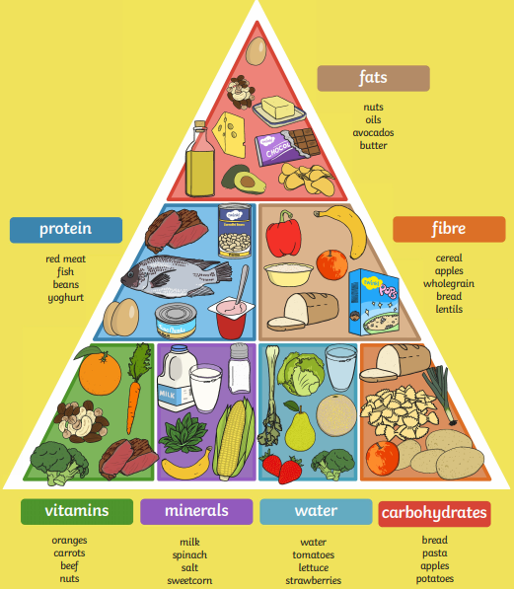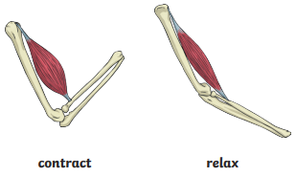

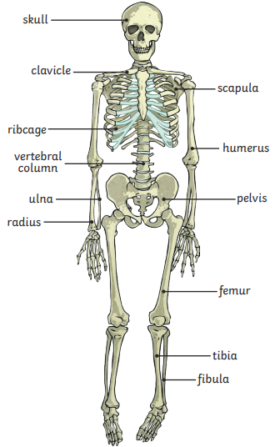

|  |
| --- |
| **Our Enquiry Questions** |
| * What makes the skeleton important? * What kind of bones are in our body? * How do muscles help us move? * Why do we need to eat? * What are the main nutrient groups? * What do we mean by balanced? |

Skeletal muscles work in pairs to move the bones they are attached to by taking turns to contract (get shorter) and relax (get longer).

**Skeletons**

Skeletons do three important jobs:

• protect organs inside the body;

• allow movement;

• support the body and stop it from falling on the floor.

**Types of nutrients**

**Protein** help your body to grow and repair itself examples include red meat, yogurt, beans.

**Carbohydrates** give you energy examples include bread, potatoes, pasta

**Fats** give you energy examples include nuts, oils, avocados

**Vitamins** keep your body healthy examples of foods high in vitamins include oranges, carrots and nuts.

**Minerals** keep your body healthy examples of foods high in vitamins include milk, sweetcorn, spinach

**Fibre** helps you to digest the food that you have eaten examples of foods high in fibre include wholegrain bread, cereals and lentils

**Water** helps to move nutrients in your body and get rid of waste that you don’t need examples of foods high in water include celery, cucumber, tomatoes.

|  |  |  |  |
| --- | --- | --- | --- |
| **F:\Learning bugs\Foundation Subjects\Dolly the Fly - Science.jpgLyng Primary School Knowledge Organiser** | | | |
| ***Topic: Movement and nutrition*** | ***Science***  ***How do our bodies function?*** | *Year 3* | *Autumn 1* |

|  |  |  |  |
| --- | --- | --- | --- |
| Which of these is not a joint? | **S** | | **E** |
| a) Elbow |  |  | |
| b) knee |  |  | |
| c) skull |  |  | |

|  |  |  |
| --- | --- | --- |
| Which is the correct order of bones from head to toe? | **S** | **C** |
| a) skull, femur, pelvis, ribs |  |  |
| b) skull, spine, pelvis, femur |  |  |
| c) pelvis, spine, humorous, skull |  |  |
|  |  |  |

|  |  |  |
| --- | --- | --- |
| What are the three functions of a skeleton? | **S** | **E** |
| 1. Movement, motion and support |  |  |
| 1. Support, strength and behaviour |  |  |
| 1. Movement, Protection and support |  |  |

|  |  |  |
| --- | --- | --- |
| Which nutrient group is used as an energy store and helps us to keep warm? | **S** | **E** |
| 1. water |  |  |
| 1. fats and oils |  |  |
| 1. minerals |  |  |

|  |  |  |
| --- | --- | --- |
| Which of these statements is false? | **S** | **E** |
| 1. Muscles are attached to our bones |  |  |
| 1. Muscles push on our bones |  |  |
| 1. Muscles make the bones move |  |  |

|  |  |  |
| --- | --- | --- |
| Which of these bones protects the heart? | **S** | **E** |
| 1. Skull |  |  |
| 1. Ribs |  |  |
| 1. Pelvis |  |  |

|  |  |  |
| --- | --- | --- |
| Which of the following do we need for energy? | **S** | **E** |
| 1. breathing |  |  |
| 1. sleeping |  |  |
| 1. running |  |  |
| 1. all of the above |  |  |

|  |  |  |
| --- | --- | --- |
| A balanced diet is… | **S** | **E** |
| 1. Eating all seven nutrients in the right amounts |  |  |
| 1. Never eating bad foods |  |  |
| 1. Eating all five nutrients in the right amounts |  |  |

Start of quiz _________________

End of quiz ________________